React JS Testing

Testing
Testing is use to find the defect or error or bugs the application.
Testing mainly divided into 2 parts
Manually testing
Automation testing

Black box testing
Input Process Output
White box testing

Input Process Output
Test the any application without main or without entry of the application.
UI Testing

Unit Testing : Unit testing is a type of white box testing which help to test function functionality working not. Unit smallest code which work independently in function or method or Component etc.
Junit
Nunit
UI Testing
Jasmine : Core JS application.
Angular by default configure jasmine with Karma testing tool.
JEST : Third party framework provided by Facebook.
React JS with JEST
Mocha with Chai
Node JS with Mocha with Chai third party library

function add(a,b) {
let sum = 0;
return sum;
}

We need html page.

React JS

App.jsx - Root component

Hello.jsx : code or dom

npm install create-react-app -g
create-react-app react-demo
when we create project using create-react-app this module by default configure jest testing library

But when we create react js project vite framework.

- Creating react js project
npm create vite@latest react-test-app
cd react-test-app
- then install below dependencies
npm install -D vitest jsdom @testing-library/react @testing-library/jest-dom
npm install -D @testing-library/user-event

- in existing vite.configure.js file replace below code
configure the vite.confiure.js

import { defineConfig } from "vite";
import react from "@vitejs/plugin-react";
export default defineConfig({
plugins: [react()],
test: {
environment: "jsdom",
setupFiles: "./src/setupTests.js",
globals: true,
},
});

- Setup Test Environment inside src folder create the setupTests.js file
src/setupTests.js
import "@testing-library/jest-dom";

- Add these code in package.json file
Inside script tags
"scripts": {
"test": "vitest",
"test:watch": "vitest --watch",
"test:coverage": "vitest run --coverage",
"test:coverage:report": "vitest run --coverage --reporter=html"
}

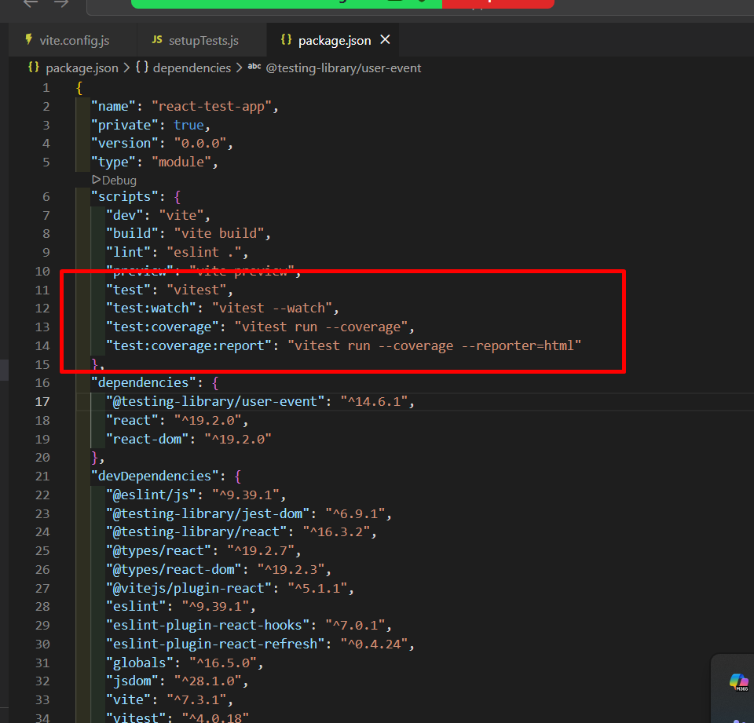

Hello.jsx

function Hello() {

return(
<div>
<h2>Hello, Vite with JEST!</h2>
</div>
)
}

export default Hello;

Hello.test.jsx

import { render ,screen} from "@testing-library/react";
import { describe, expect } from "vitest";
import Hello from "./Hello";

// it is container which hold more than one test case
describe("Hello Component Testing ",()=> {

// it is used to write single test case
test("Hello Component should render correctly", ()=> {
render(<Hello />)
expect(screen.getByText("Hello, Vite with JEST!")).toBeInTheDocument();
})

})

To run the application
npm run test

1 simple component return JSX code : testing done
2. login component testing with 3 test cases
a. required field
b. failure
c. success
3. component call external service like rest api
In same project install axios dependencies
npm install axios

Testing for actual rest api
Mock for rest api

